**Weekly Progress Report**Jerry Wang 4/7~4/10

**Study Team Developer Tool**

* Github : version control(gitflow)、continuous integration (travis-ci)
* Redmine: Multiple projects support、SCM integration、 bug tracking
* Hipchat:Group chat、Save chat log

**Google map api v3 analysis**

main functional menus - Monitor submenus for site networks  
A.Map & floor coverage

[**MapTypeStyle**](https://developers.google.com/maps/documentation/javascript/reference#MapTypeStyle)：Google map styles election (<https://snazzymaps.com/>) **Overlays**

* [Circle](https://developers.google.com/maps/documentation/javascript/3.exp/reference#OverviewMapControlOptions) define network range
* [Marker labels](https://developers.google.com/maps/documentation/javascript/3.exp/reference#OverviewMapControlOptions) Define device number

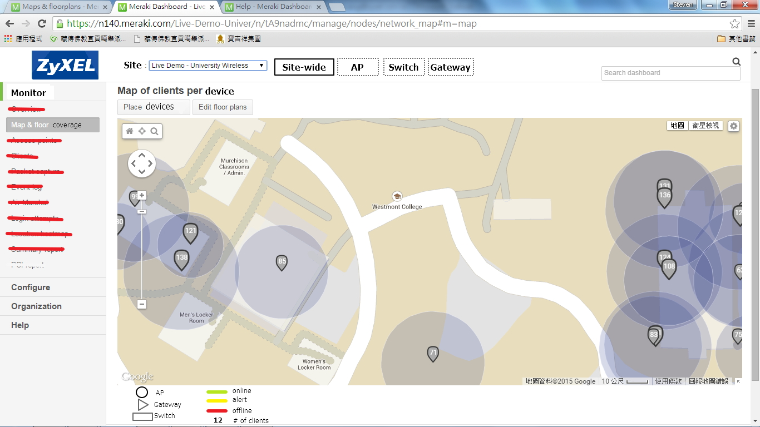

Use the buttons on the automatic scaling tool to geo-align the floorplan on top of Google maps; it is possible to shrink or enlarge the map, as well as rotate it.



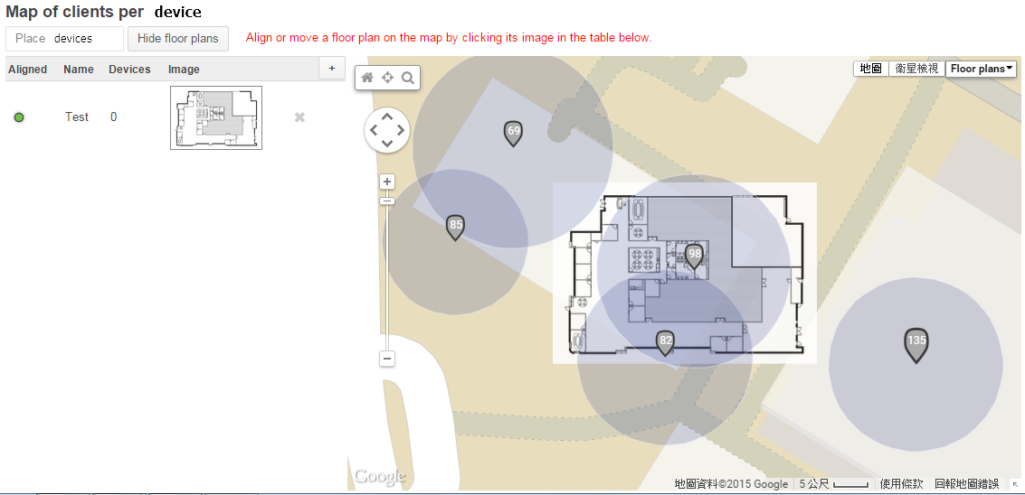

* [OverlayView](https://developers.google.com/maps/documentation/javascript/3.exp/reference#OverlayView) add floorplan of upload
* [OverviewMapControlOptions](https://developers.google.com/maps/documentation/javascript/3.exp/reference#OverviewMapControlOptions) control floorplan of upload